Social Studies 20-1

ASSIGNMENT BOOKLET 4A

- Visions of Canada

SENIOR HIGH SCHOOL
Fort Saskatchewan 780 992 0101
Sherwood Park 780 464 1899
Vegreville 780 632 7998

Social Studies 20-1 Chapter 13: Visions of Canada
_______________________________________________________

1. (Page 295) Fill in the information for the chart on the lines below the chart.

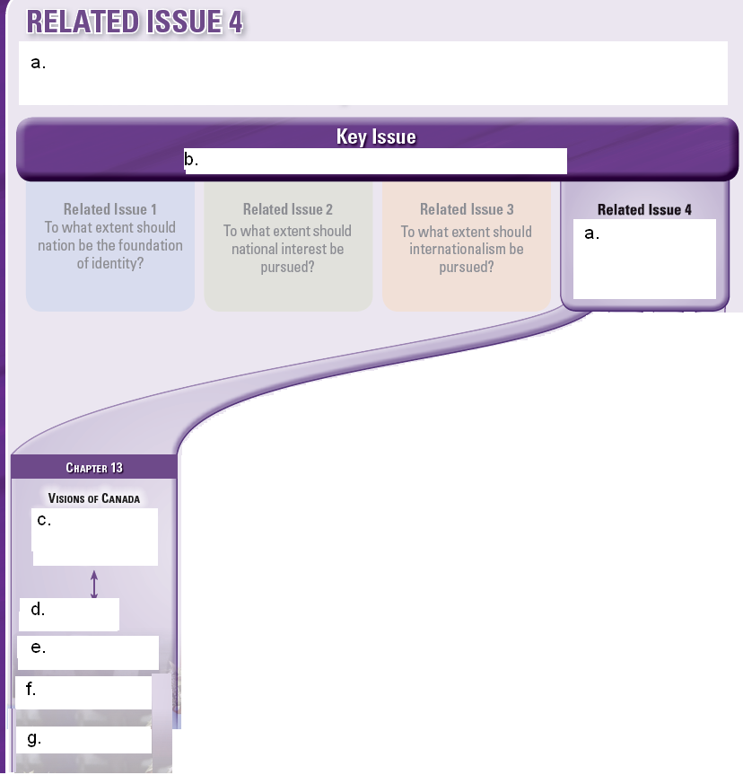

a.

b.

c.

d.

e.

f.

g.

2. (Page 295) The Big Picture

a) What are the first four related issues for the course? Check back to the Related Issue Charts located in various parts of the textbook.

Related Issue 1:

Related Issue 2:

Related Issue 3:

b) Write a short personal response to the information you have been analyzing in this course so far by answering the following question:

Five years from now, when you have forgotten about a lot of things you’ve done in grade 11 social studies, what two things from this course so far that are useful and worth remembering?

c) (Page 295) The Big Picture (continued)

What are two opposite opinions of the effects of nationalism?

VERSUS

Which side does Canada seem to lean more towards? Give one piece of evidence for your response.

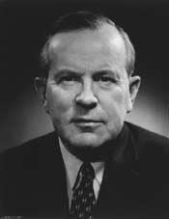
d) Choose a quote from Lester B. Pearson, write it in the speech window below, then explain why you like it.

Quote:

Explanation:

4. (Page 300) What is Canada?

National identity involves a ________________________________________ to a

collective or __________________________.

When a nation has a _____________________________ defined identity, individuals

and ________________________who have internalized this ____________________

are much more ________________________ to affirm and ______________________

a ___________________________ identifiable identity.

Nationalism and _____________________ are often _______________________.

5. (Page 300) Differing Visions of Canada

a) Why do you think it is so hard for Canadians to define Canada’s identity?

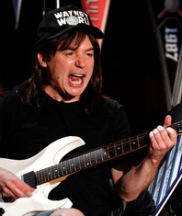
b) How does Mike Myers define Canada?

c) What does Susan Delacourt mean when she says:


To be Canadian means to
be willing to shrug off your own identity so you can imagine what it’s like to be someone else.

D) INTERNET SEARCH: HOW ABOUT RYAN REYNOLDS? HOW DOES HE DEFINE CANADA & HOW IS HE A CONTRIBUTING CITIZEN?

6. (Page 301) Summarize the ideas from each category

Canadian Identity and Geography

One Canada

Pluralistic and Multicultural

Communities and Nations within a Nation:

7. (Page 304) How and why did early visions of Canada emerge?

a) What is it that often provides a foundation for the national identity of former colonies?

b) Read the lyrics for both the United States national anthem and the Canadian national anthem. Highlight or underline phrases from each song that show a great pride in national identity.

The Star Spangled Banner

Oh, say can you see by the dawn's early light
What so proudly we hailed at the twilight's last gleaming?
Whose broad stripes and bright stars thru the perilous fight,
O'er the ramparts we watched were so gallantly streaming?
And the rocket's red glare, the bombs bursting in air,
Gave proof through the night that our flag was still there.
Oh, say does that star-spangled banner yet wave
O'er the land of the free and the home of the brave?

c)
O Canada!
Our home and native land!
True patriot love in all thy sons command.
With glowing hearts we see thee rise,
The True North strong and free!
From far and wide,
O Canada, we stand on guard for thee.
God keep our land glorious and free!
O Canada, we stand on guard for thee.
O Canada, we stand on guard for thee.

** One line of our anthem has changed to “in all of us command.”

What is one basic similarity or difference between the two anthems?

8. (Page 304) Working together to achieve responsible government

a) Add some more information to the timeline.

1791

1841

The British plan was to:

By 1848

b) How does responsible government work?

9. (Page 305) Confederation: A New Vision of Canada

a) Read the five paragraphs in this section. Explain how the American Civil War had an impact on the creation of the British North America Act.

b) (Page 305) Figure 13-4

What exactly is happening in the political cartoon? In your response, provide analysis of what each of the three character represents, what they are thinking, and the emotions that they express.

10. (Page 307) Evolving Visions of Canada

Explore the goals of the following people and people groups. Examine how you think they achieved their goals—or tried to achieve their goals.

Person/People | What did they want? | How did they achieve their goals?
John A. Macdonald

Aboriginal People

Wilfred Laurier

Clifford Sifton

Immigrants

Francophones

11. (Page 308) To what extent did various early visions of Canada meet people’s
needs?

a) (Page 308) Figure 13-6

Carefully analyze the information about Languages in Canada. What conclusions can you come to about the changes over time?

b) As a result of the changes the numbers of people who speak French, what are three options many Québec Francophones came to believe they had?

If you were a Québec Francophone, what option would you gravitate towards, and why?

12. (Page 308-309) The Growth of French-Canadian Nationalism

a) What was the underlying threat that many Québécois felt as immigration to Canada was promoted?

b) What did Henri Bourassa believe in, and how did it affect his influence over the people of Québec?

c) (Page 309) In what ways can you see that Québec nationalism is related to the Catholic religion?

d) By the time [Duplessis] died, in 1959, many Francophone Québécois were ready to embrace what came to be called the Quiet Revolution.

What did the people want?

Use the index of the textbook, pages 392-401, and find the heading “Quiet Revolution.” Look up the other reference for the Quiet Revolution, and explain what happened in Québec during the Quiet Revolution.

e) In a paragraph, examine the roles that René Lévesque and Pierre Trudeau had in achieving Québec’s goals.

b) In point form, write out 10 quick facts from page 311 that explore the racism that was happening in Canada between 1885 to 1971.

1.
2.
3.
4.
5.
6.
7.
8.
9.
10.

14. (Page 316) The Founding Nations Debate
a) What did schools used to teach and what was wrong with it?

What is the concept of the “three founding nations” and why is it controversial?

15. (Page 316-317) The Multiculturalism Debate

a) What was discovered in the 2007 study by the Institute for Research on Public Policy?

b) Summarize the short speeches by John Ibbitson and Neil Bissoondath, then write two to three sentences that analyze the differences between their ideas.

c) Debates about multiculturalism suggest that visions of Canada are very different. In a paragraph of 5 to 7 sentences, evaluate whether or not you believe the debate between Ibbitson and Bissoondath is a sign of a healthy society. Give several reasons and examples to support your evaluation.

Chapter 14

Read through this brief chapter, then answer the following question.

- How important do you believe a shared Canadian identity is in shaping our society today? In your opinion, which institutions or symbols best represent that identity, and why?

- The Hudson's Bay Company, one of the oldest companies in North America, has faced store closures and significant changes in recent years. What impact do you think the loss of such long standing Canadian institutions has on our national identity and cultural heritage? (page 328)

SUBMIT MODULE 4A TO BRIGHT SPACE AND COMPLETE MODULE 4B

